Lab - Troubleshoot Inter-VLAN Routing

Topology
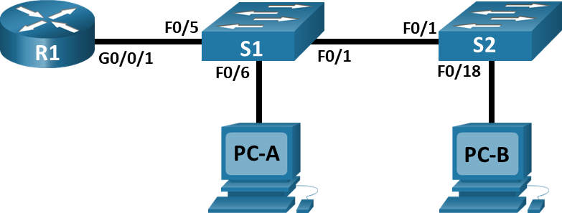

Addressing Table
Device | Interface | IP Address | Subnet Mask | Default Gateway
R1 | G0/0/1.3 | 10.3.0.1 | 255.255.255.0 | N/A
R1 | G0/0/1.4 | 10.4.0.1 | 255.255.255.0 | N/A
R1 | G0/0/1.13 | 10.13.0.1 | 255.255.255.0 | N/A
S1 | VLAN 3 | 10.3.0.11 | 255.255.255.0 | 10.3.0.1
S2 | VLAN 3 | 10.3.0.12 | 255.255.255.0 | 10.3.0.1
PC-A | NIC | 10.4.0.50 | 255.255.255.0 | 10.4.0.1
PC-B | NIC | 10.13.0.50 | 255.255.255.0 | 10.13.0.1

VLAN Table
VLAN | Name | Interface Assigned
3 | Management | S1: VLAN 3  S2: VLAN 3
4 | Operations | S1: F0/6
7 | ParkingLot | S1: F0/2-4, F0/7-24, G0/1-2  S2: F0/2-17, F0/19-24, G0/1-2
8 | Native | N/A
13 | Maintenance | S2: F0/18

Objectives
Part 1: Evaluate Network Operation
Part 2: Gather information, create an action plan, and implement corrections

Background / Scenario
Your instructor has preconfigured all the network equipment and has included intentional errors that are keeping the inter-VLAN routing from working. Your task is to evaluate the network and identify and correct the configuration errors to restore full connectivity. You may find errors with the configurations which are not directly related to inter-VLAN routing that impact the ability of the network devices to perform this function.
Note: The design approach used in this lab is to assess your ability to configure and troubleshoot inter-VLAN routing only. This design may not reflect networking best practices.
Note: The router used with CCNA hands-on labs it the Cisco 4221 with Cisco IOS XE Release 16.9.4 (universalk9 image). The switches used in the labs are Cisco Catalyst 2960s with Cisco IOS Release 15.2(2) (lanbasek9 image). Other routers, switches, and Cisco IOS versions can be used. Depending on the model and Cisco IOS version, the commands available and the output produced might vary from what is shown in the labs. Refer to the Router Interface Summary Table at the end of the lab for the correct interface identifiers.
Note: Ensure that the routers and switches have been erased and have no startup configurations. If you are unsure contact your instructor.

Required Resources
- 1 Router (Cisco 4221 with Cisco IOS XE Release 16.9.4 universal image or comparable)
- 2 Switches (Cisco 2960 with Cisco IOS Release 15.2(2) lanbasek9 image or comparable)
- 2 PCs (Windows with a terminal emulation program, such as Tera Term)
- Console cables to configure the Cisco IOS devices via the console ports
- Ethernet cables as shown in the topology

Instructions

Evaluate Network Operation.
Note: You may need to disable the Windows Firewall on PC–A and PC–B.
Requirement:
- No VLAN 7 trunk traffic because there is no devices in VLAN 7.
- VLAN 8 is the native VLAN.
- All trunks are static.
- End to end connectivity
Use Ping to test the following criteria and record the results in the table below.
From | To | Ping Results
R1 | S1 VLAN 3 (10.3.0.11) | blank
R1 | S2 VLAN 3 (10.3.0.12) | blank
R1 | PC-A (10.4.0.50) | blank
R1 | PC-B (10.13.0.50) | blank
S1 | S2 VLAN 3 (10.3.0.12) | blank
S1 | PC-A (10.4.0.50) | blank
S1 | PC-B (10.13.0.50) | blank
S2 | PC-A (10.4.0.50) | blank
S2 | PC-B (10.13.0.50) | blank

Gather information, create an action plan, and implement corrections.
      - For each criterion that is not met, gather information by examining the running configuration and routing tables and develop a hypothesis for what is causing the malfunction.
      - Create an action plan that you think will fix the issue. Develop a list of all the commands you intend to issue to fix the issue, and a list of all the commands you need to revert the configuration, should your action plan fail to correct the issue.
Hint: If you need to reset a switchport to default configuration, use the command default interface interface name.
As an example for F0/10:
S1(config)# default interface f0/10
      - Execute your action plans one at a time for each criterion that fails and record the fix actions.
Type your answers here.
End of document

